CENWP-OD-G 10/10/2018

MEMORANDUM FOR THE RECORD 18 LGS 20 Unit Priority Violation

SUBJECT: Little Goose unit priority violation

Background
Little Goose Lock and Dam experienced a 15 kv ground fault causing Unit 1 and breaker XJ-7 to trip. The unit was forced out of service from 23:05 on October 6 through 14:45 on October 7. During this period, Little Goose was unable to operate within unit priority as outlined in the Fish Passage Plan (Chapter 8-Little Goose Dam, Table LGS-5). At that time, Little Goose was forced to operate Unit 3 next unit within priority as Unit 2 is out for annual maintenance (Table 1). Additionally, breaker XJ-7, which feeds power to the juvenile fish facility, remains out of service for troubleshooting. The juvenile fish facility is currently operating on an emergency diesel generator.
Path Forward
Engineers and electricians are currently analyzing data to determine the cause of the 15 kv ground.
Relevance to Adult Fish Passage
Unit 1 is the priority unit for adult fish attraction flow. Currently Little Goose is nearing the end of peak passage for both Fall Chinook salmon and steelhead (Fish Passage Plan, Chapter 7-Little Goose, Table LGS-4). However, adult passage remains relatively high (Figure 1 & 2) with 169 Fall Chinook salmon and 1132 steelhead passing Little Goose on October 7.
Estimated mortalities by species, and origin:

- Species – N/A
- Origin – N/A
- Length – N/A
- Marks and tags – N/A
- Marks and Injuries found on carcass – N/A
- Cause and Time of Death – N/A
- Future and Preventative Measures – N/A

Table 1: Little Goose Dam turbine unit annual maintenance schedule.
Turbine Unit | Out of Service | Return to Service | Description
2 | 10/01/2018 | 10/19/2018 | Annual Maintenance
3 | 10/22/2018 | 11/16/2018 | Annual Maintenance

Figure 1: Adult Chinook salmon counts at Little Goose Dam; 2018 and 10-year average.
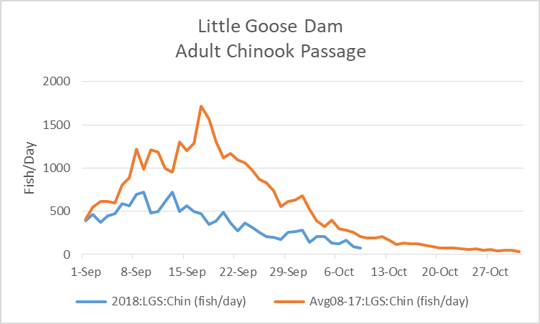

Figure 2: Adult steelhead counts at Little Goose Dam; 2018 and 10-year average.
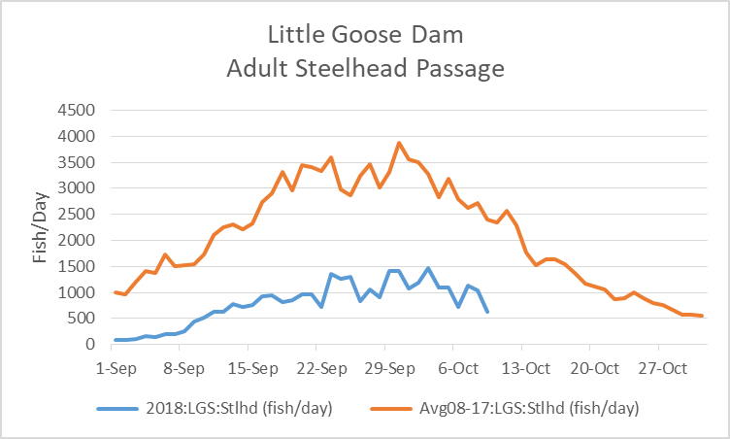

Sincerely,
Scott St. John
Project Fisheries Biologist
Little Goose Dam
(509) 399-2233 ext. 263
Scott.St.John@usace.army.mil

